FAQ – Hub Coordinator and Information Assistant
- How are the posts funded?
The posts are funded through the Social Value Forum Development Fund. This is part of a multi agency strategy in Powys; more details can be found here.

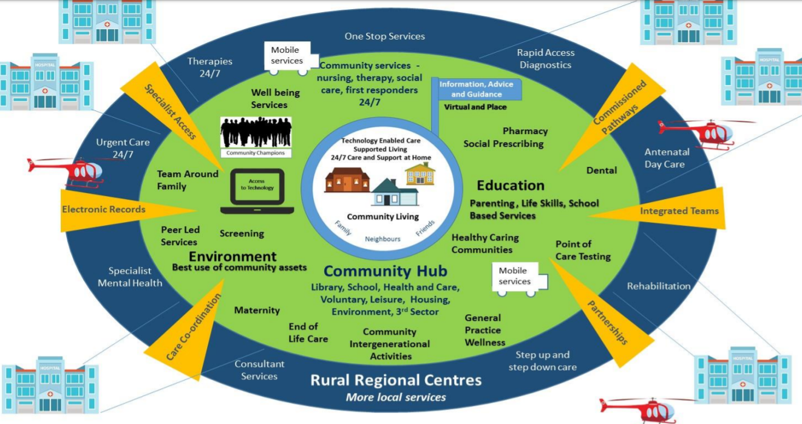

The posts are only funded until March 2020, but there is a possibility of further funding for the Hub Co-ordinator after April 2020.

- Why has the Hub been developed at the Knighton Community Centre?

The Comm had a comprehensive review in 2014 and decided to develop as a Hub for local services. Subsequently, the Welsh Assembly Government and Powys County Council funded a comprehensive refurbishment. This took place in 2017.

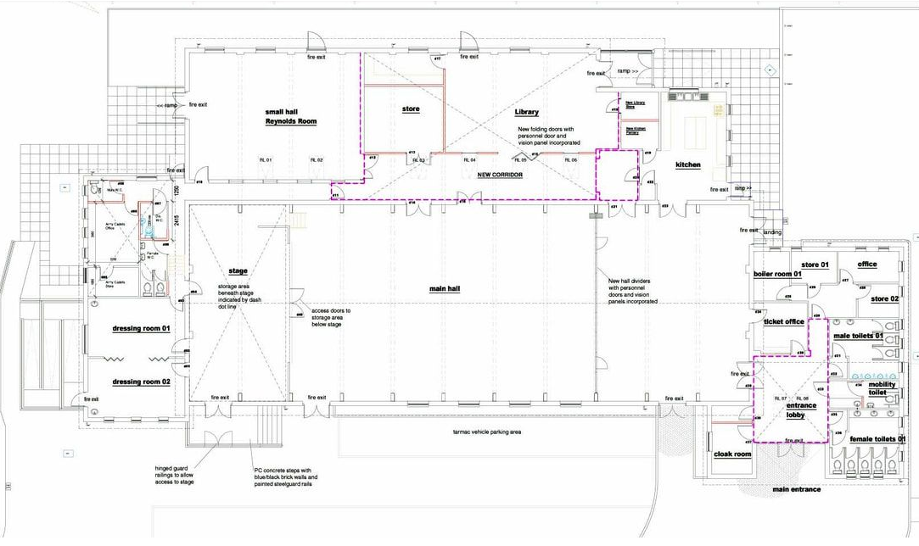

- Has there been public consultation?

There was extensive public consultation about the original plan for the Community Centre. The Community Centre has recently consulted with people in Knighton about priorities for the future. See this summary

- Who else works at the Comm?
Ceri Brown Administrator; Louise Hardwick Volunteer Coordinator; Chris Martin Caretaker/Playworker; Hannah Isaacson Librarian (PCC); Di and Helen (Cleaners). Dave Alker is the Chair of the Management Committee and though he is a volunteer, he is often there. We also have a large team of volunteers who run cafes, bars, Flicks, help with the market, support the Committee and work in the library and literary festival.
- What services have already been developed?
Library, Army Cadets, Leg Club, Bracken Trust, Family Fitness, Yoga, Welsh classes, Creative Writing, Flicks in the Sticks, Saturday Community Markets, Volunteer Bureau (delivery partner for PAVO), Stay and Play, Bounce and Rhyme, PAVO Community Connector, St Edwards Drop In (jointly with St Edwards Church), Credu Carers, Prime Cymru, Job Centre drop ins, Housing advice and the Tuesday café. We are also a centre for elections, blood donation, breast screening, weddings, funerals and parties and have held two Literary Festivals. Our AGM report describes progress in the past year.
- Is there office accommodation for the new posts?
Office accommodation and storage is very limited.
- What are the priorities for the posts?
Hub Coordinator: to develop new services, train volunteers in signposting and form filling and work with other services in Knighton, all with the aim of giving citizens a coherent service. Information Assistant: to develop a Register of local groups and to input this information on to national databases eg Dewis.
- Will IT equipment be provided?
Yes, we hope to provide a laptop and printer.
- Can I work flexibly/work from home?
Yes. There will be a need for the occasional evening / weekend sessions.
- What are the links with other services?
There are excellent relationships with Powys County Council and there are good links with Churches Together who run a range of services including the Monday Lunch Club and the Food Bank and also Knighton Church in Wales Primary School. There is also Knighton Community Support who run community transport and a furniture recycling service (‘The Barn’). The Knighton Museum is run by volunteers. There is a dementia group (KINDA). Though there are good relationships with the surgery and the Health Visitors, these need to be developed. Services for families and children are underdeveloped. We have recently lost our slimming group in Knighton and it will be a priority to establish another group.
- Where can I find demographic information about Knighton?
The Wales Index of Multiple Deprivation shows deprivation by small areas. See here. There are particular issues about educational achievement in Knighton.
- Will I receive support and supervision in undertaking the job?
We hope to have regular meetings with the Hub Coordinator, who will support the Information Assistant, and to establish a hub sub to support the project. The Hub Coordinator will have a nominated supervisor from the Management Committee.

